R AND POWER BI PROJECT



ROHIT GOKANI

Table of Contents

Introduction 2

R Studio 3

Launch R Studio 3

Data Downloaded 4

Load Data 4

Initial Exploratory Analysis​ 10

Import library 10

Check data types 11

Check for missing values 12

Drop missing values 13

Summary Statistics 14

R Visualisations 15

Export clean data 17

Power BI 18

Brief 18

Step 1 18

Visual one 20

Visual Two. 21

Visual Three 21

Visual Four 22

Visual Five 22

The Polish 23

Setting the Theme 23

Result 24

# Introduction

The Hollywood film industry is a dynamic and influential sector that has captivated global audiences for decades. This project aims to analyse the performance of Hollywood movies released between 2007 and 2012, focusing on key metrics such as title, genre, studio, profitability, and ratings. By examining these factors, we seek to uncover trends and insights that can inform future film production and marketing strategies.

The data for this analysis is sourced from InformationIsBeautiful.net, a reputable provider of visualized data insights. The dataset includes comprehensive information on various aspects of Hollywood movies, enabling a detailed examination of their performance. The data can be accessed and downloaded from the following link: Hollywood’s Most Profitable Stories.

Data analysis will be conducted in R Studio and visualized in Power BI. This approach will provide valuable insights into the factors that contribute to a movie’s success, helping studios and filmmakers make informed decisions in an ever-evolving industry.

# R Studio

R Studio is a robust integrated development environment (IDE) tailored for the R programming language, which is extensively used for data analysis and statistical computing. It enables users to write and execute R code with ease, offering features such as syntax highlighting, code completion, and an interactive console. R, known for its versatility, excels in data manipulation, visualization, and statistical modeling. Using RStudio allows data analysts and scientists to optimize their workflow, manage projects efficiently, and generate reproducible research. From data importation to complex analysis and detailed plotting, RStudio offers a comprehensive platform to enhance the R coding experience.

### Launch R Studio

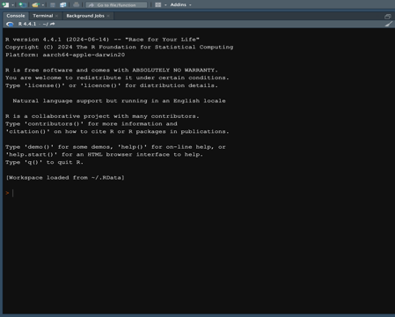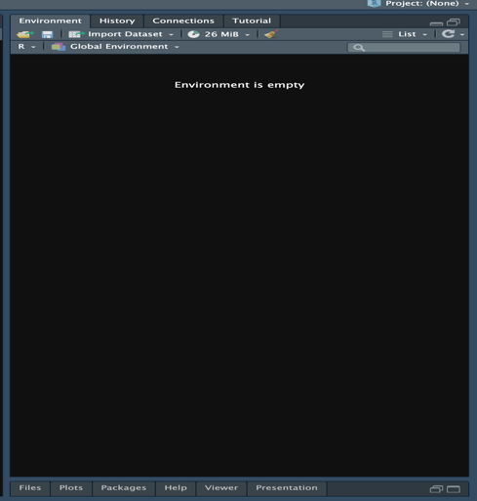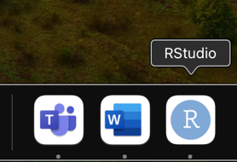

### 

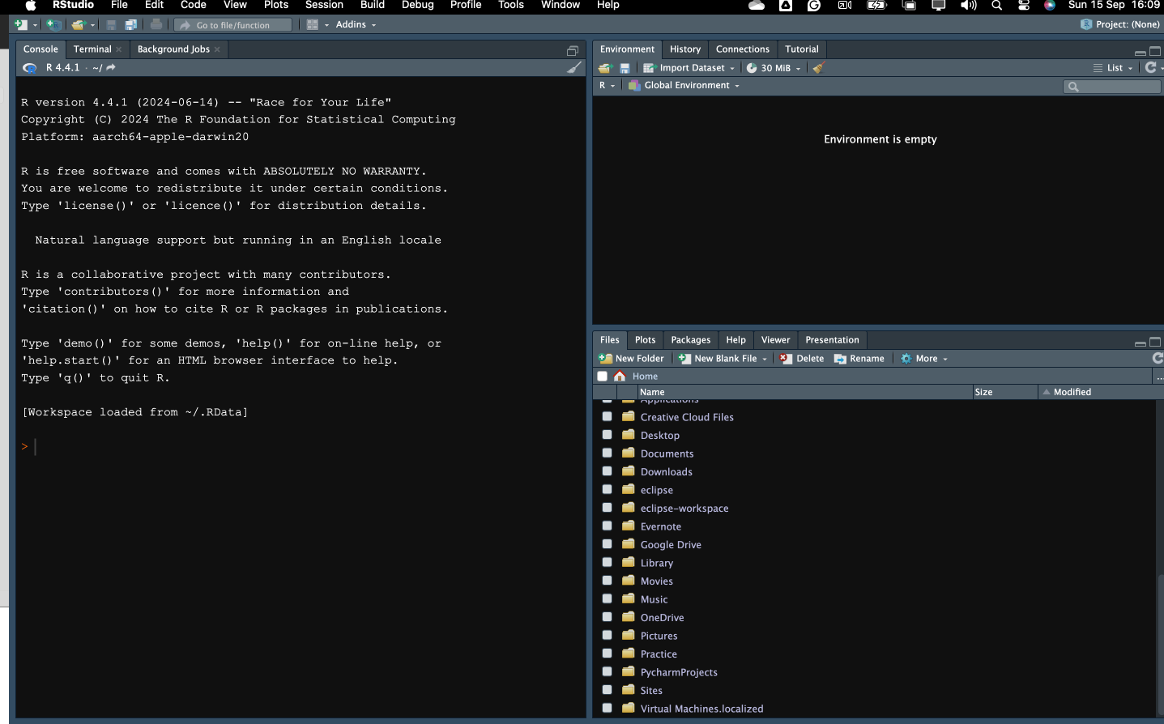

Top Left Pane: Source  
This section is where you write and modify your R scripts. Multiple scripts can be opened in tabs, allowing for easy navigation between different segments of code.

Bottom Left Pane: Console

This area allows the running of R code and view the output instantly.

Top Right Pane: Environment/History

* Environment Tab: Lists all the objects (like datasets, variables, and functions) currently in your R session. It helps you keep track of what you’ve created and loaded.
* History Tab: Shows a history of all the commands you’ve executed in the Console. You can easily reuse previous commands from here.

Bottom Right Pane: Files/Plots/Packages/Help/Viewer

Files Tab: Allows you to navigate through your file directories and manage your files.

Plots Tab: Displays any plots or graphs you generate in your R session.

Packages Tab: Lists all the R packages installed and allows you to load or update them.

Help Tab: Provides access to R documentation and help files.

Viewer Tab: Used for viewing local web content, such as HTML files or web apps created with Shiny.

### Data Downloaded

From this link below the “HollywoodsMostProfitableStories (1).csv” data was downloaded an saved to the Project 3 file.

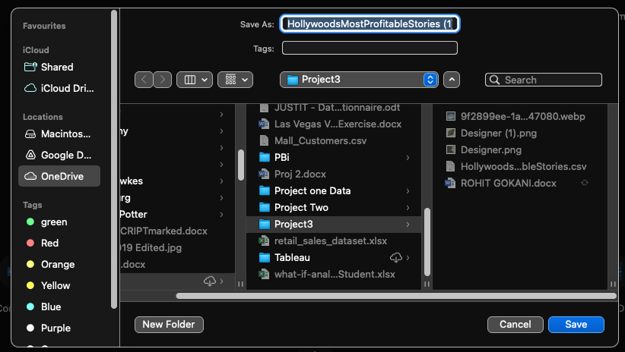<https://public.tableau.com/app/sample-data/HollywoodsMostProfitableStories.csv>

### Load Data

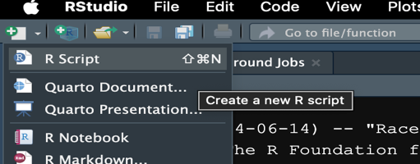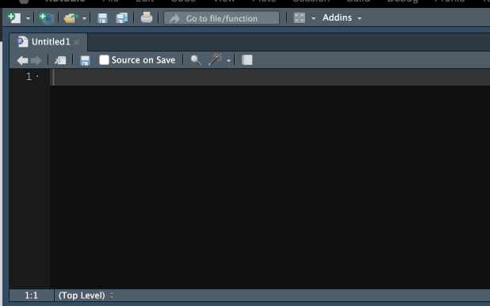

New script created

From the bottom right pane: Files/Plots/Packages/Help/Viewer > One drive> JustIT > project3. Right click> ~/OneDrive/Just IT/Project3/HollywoodsMostProfitableStories.csv > Import Dataset

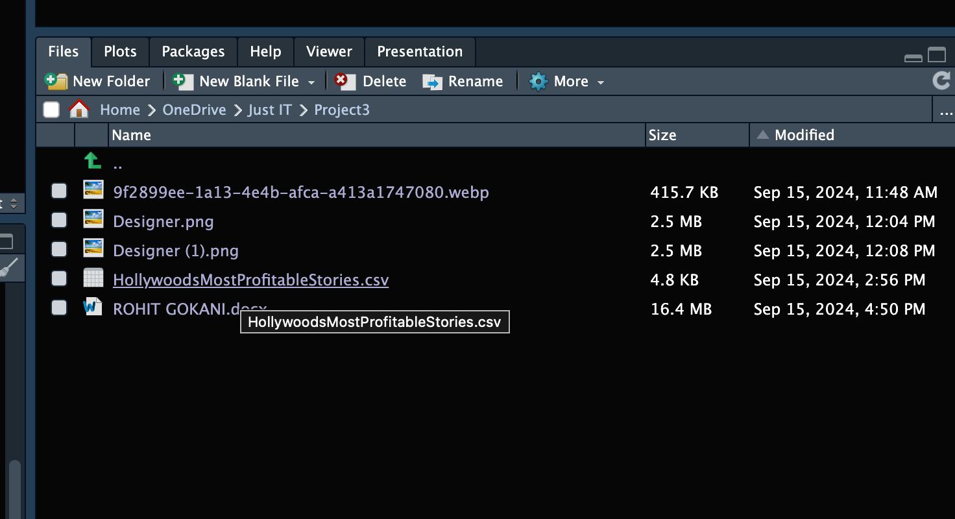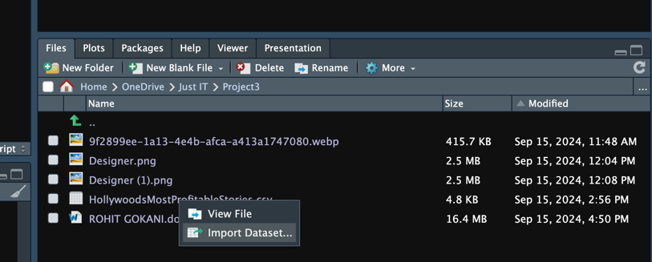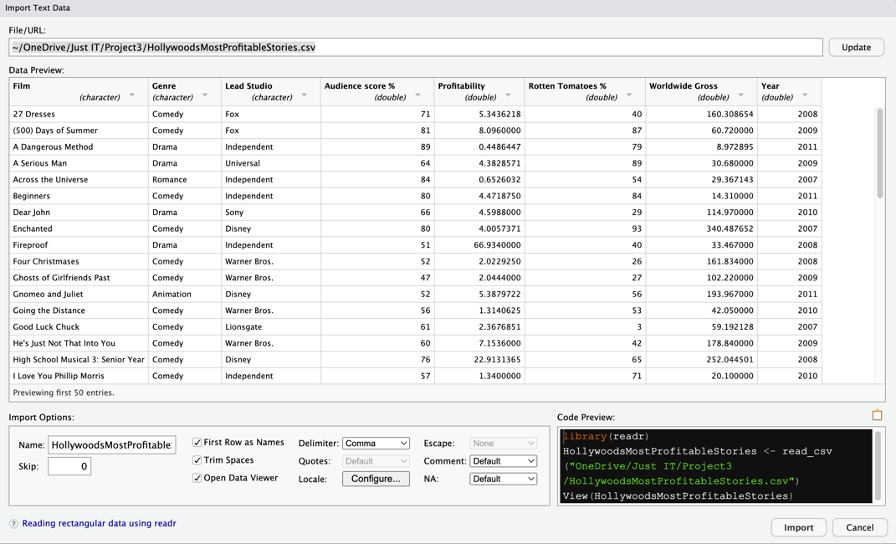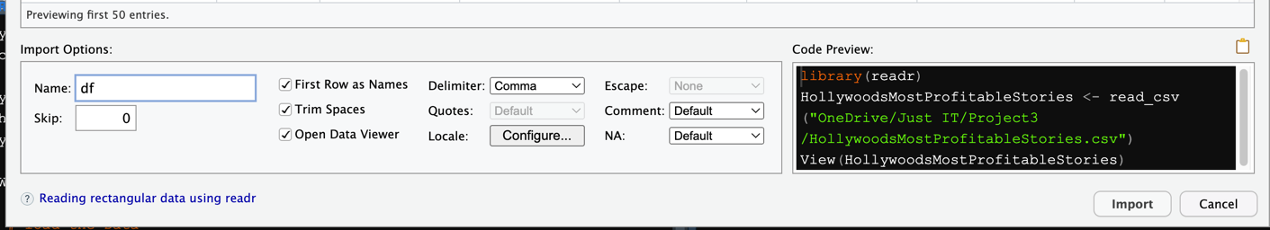

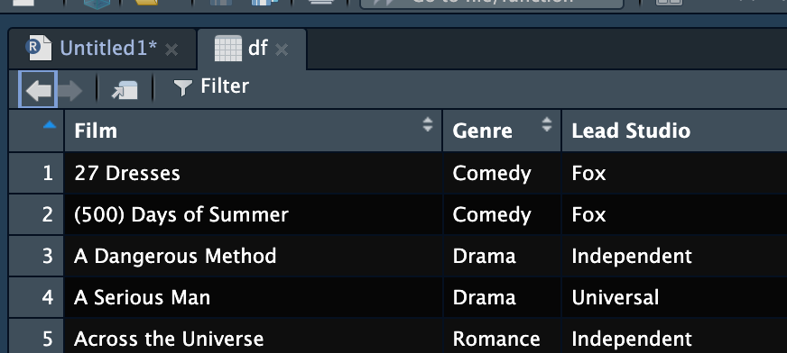

File renamed to **“df”.**

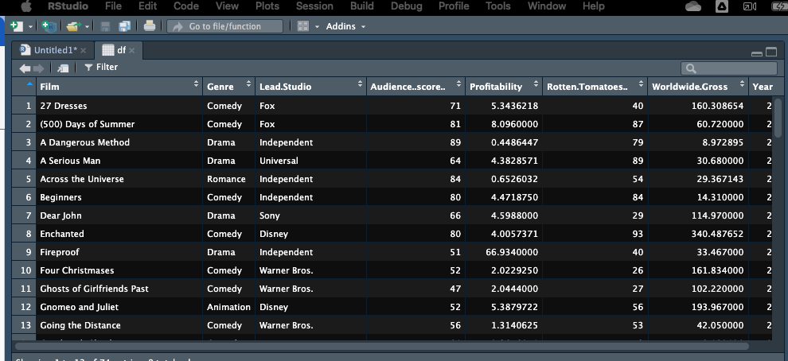In the top left pane: source with the code: “df<read.csv ("https://public.tableau.com/app/sample- [data/HollywoodsMostProfitableStories.csv](https://public.tableau.com/app/sample-data/HollywoodsMostProfitableStories.csv)")” the data was loaded and with the “View(df)” code the data can be viewed.

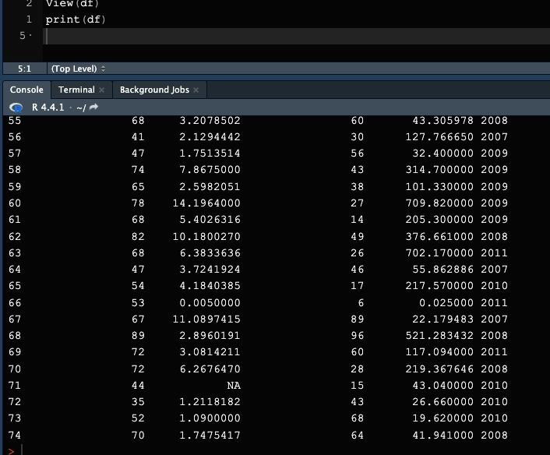

The data contains 8 columns

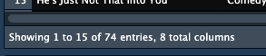

Using**print(df**) prints the entire dataset to the console:

Using**head()**and**tail()** show the first and last few rows of the dataset, respectively:

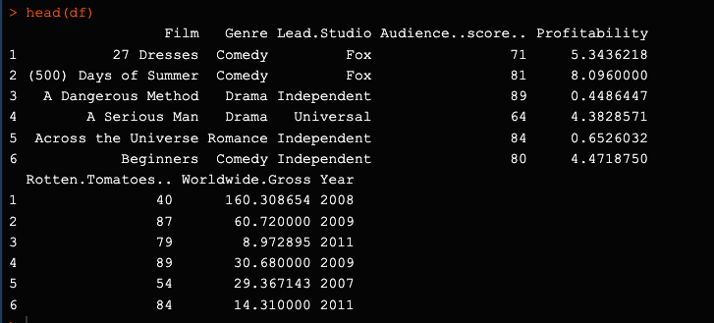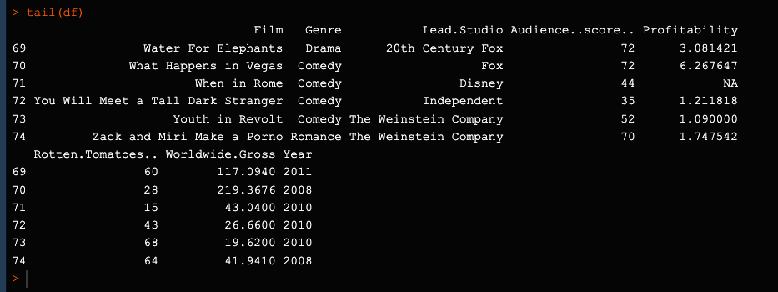

**Using summary()** gives a summary of each column in the dataset:

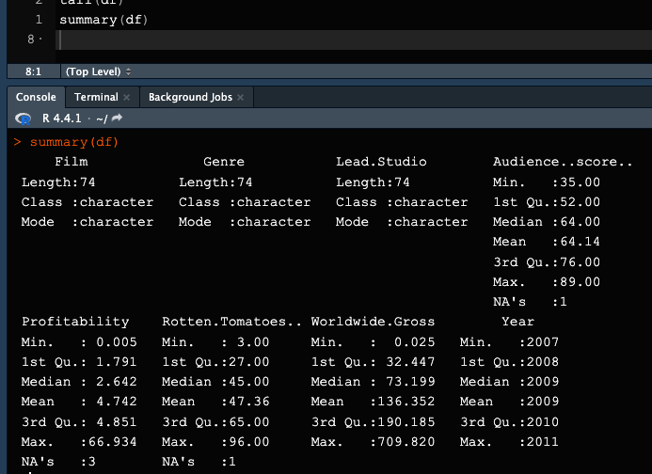

Count of the total number of rows is obtained using the total_rows <- nrow(df) in this code the “total row” variable is assigned to (<-) nrow(df) and the print(total_rows) function shows the output in the console:

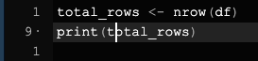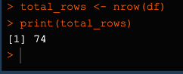

Total number of rows is 74.

Count of the total number of columns is obtained using the **ncol(df)** in this code the “total_columns” variable is assigned to (<-) ncol(df) and the print(total_columns) function shows the output in the console:

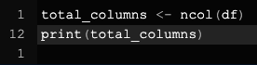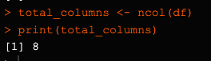

Total number of columns is 8.

**colnames()** or **names()** function can be utilised to output the names of the columns in this code the “column_names” variable is assigned to (<-) colnames(df) and the print(column_names) function shows the output in the console:

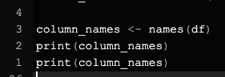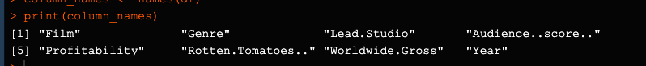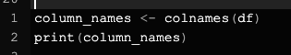

The **str(**) function in R provides a concise overview of an object's structure, including the data types of its components. When applied to a data frame, it displays information about the number of rows, columns, and the data type of each column.

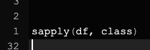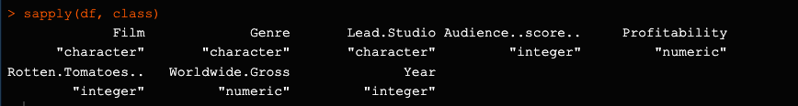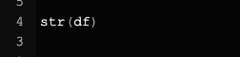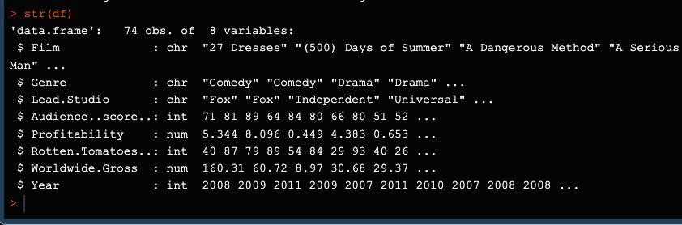

Combining **sapply()** and **class()** in R allows you to efficiently determine the data types of all columns within a data frame.

**sapply():** This function applies a specified function to each element of a list or vector.

**class():** This function returns the class or data type of an R object.

By using **sapply()** with the class() function on a data frame, you can iterate through each column and obtain its data type. This is particularly useful for understanding the structure of your data and ensuring data consistency.

**In R, you can use several functions to identify null (NA) values within your data.** These functions provide different ways to locate and handle missing data effectively.

**Common methods include:**

* 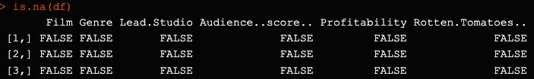**is.na():** Directly checks if a value is NA.

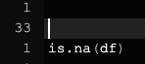

* 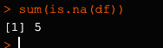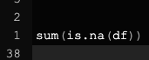**sum(is.na(x)):** Counts the number of NA values in a vector or data frame.
* 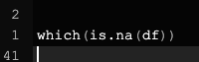**which(is.na(x)):** Returns the indices of NA values in a vector or data frame.

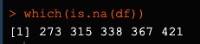

* 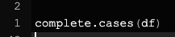**complete.cases():** Identifies complete rows (without NA values) in a data frame.

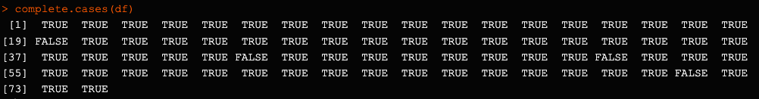

* **Specialized packages:** Libraries like naniar and missmap offer additional tools for working with missing data.

By understanding these methods, you can effectively manage and handle missing values in your R data analysis.

## Initial Exploratory Analysis​

### Import library

The **tidyverse** is an essential suite of R packages tailored for data science. It provides a unified set of tools that integrate smoothly, enhancing the efficiency and intuitiveness of data manipulation and analysis. The primary packages include:

* **ggplot2**: For crafting visually compelling data visualizations.
* **dplyr**: For manipulating data frames, including operations like filtering, grouping, and summarizing.
* **tidyr**: For reshaping data into a consistent format.
* **readr**: For importing various data formats, such as CSV and TSV files.
* **purrr**: For applying functional programming techniques to data frames and lists.
* **tibble**: For working with modern data frames that offer improved features and performance.
* **stringr**: For efficient string and text data manipulation.
* **forcats**: For handling factors, which are categorical variables in R.

Utilising these packages together can streamline your data analysis workflow, making your code more readable and maintainable. The tidyverse’s cohesive design philosophy and shared data structures make it an invaluable resource for data scientists and analysts.

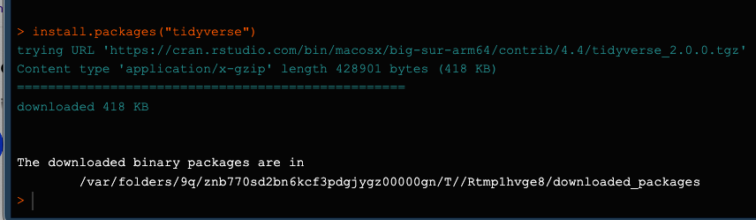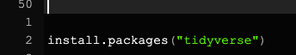

### Check data types

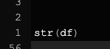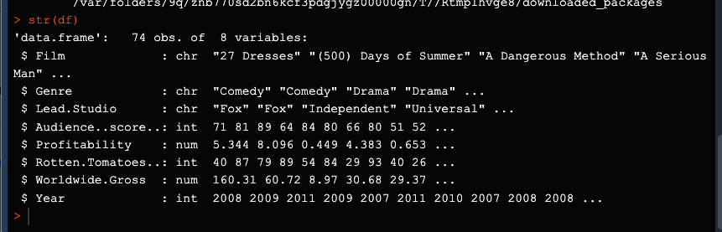The **str(df)** function in R provides a compact, human-readable summary of the structure of a data frame. Here’s an analysis of the output you provided:

**Data Frame Overview**

**Number of Observations (Rows)**: 74

**Number of Variables (Columns)**: 8

**Variables**

**Film**:

* Type: Character (chr)
* Description: Titles of the films.
* Example Values: “27 Dresses”, “(500) Days of Summer”, “A Dangerous Method”, “A Serious Man”
* **Genre**:
* Type: Character (chr)
* Description: Genre of the films.
* Example Values: “Comedy”, “Drama”

**Lead.Studio**:

* Type: Character (chr)
* Description: The main studio that produced the films.
* Example Values: “Fox”, “Independent”, “Universal”

**Audience…score…**:

* Type: Integer (int)
* Description: Audience score, likely from a review aggregator.
* Example Values: 71, 81, 89, 64

**Profitability**:

* Type: Numeric (num)
* Description: Profitability ratio of the films.
* Example Values: 5.344, 8.096, 0.449, 4.383

**Rotten.Tomatoes…**:

* Type: Integer (int)
* Description: Rotten Tomatoes score.
* Example Values: 40, 87, 79, 89

**Worldwide.Gross**:

* Type: Numeric (num)
* Description: Worldwide gross revenue in millions.
* Example Values: 160.31, 60.72, 8.97, 30.68

**Year**:

* Type: Integer (int)
* Description: Year of release.
* Example Values: 2008, 2009, 2011, 2007

This summary gives a quick glance at the data types and some example values for each variable in your data frame.

### Check for missing values

Identifying and managing missing values in R is crucial for maintaining data integrity, enhancing model performance, and ensuring overall data quality.

* **Data Integrity**: Missing values can skew statistical calculations and lead to biased analyses, which compromises the accuracy of your results.
* **Model Performance**: Many statistical models and machine learning algorithms require complete datasets to function effectively. Ignoring missing values can result in model instability and inaccurate predictions.
* **Statistical Power**: Addressing missing values through imputation or removal helps maintain a sufficient sample size, which is essential for detecting meaningful patterns and effects in your data.
* **Data Quality**: Identifying missing values allows you to assess the quality of your data collection process and pinpoint potential issues that need to be addressed.
* **Error Prevention**: Using functions like na.rm in R enables you to skip over missing values during calculations, preventing errors and ensuring reliable results.

The colSums(is.na(df)) function in R is a useful tool for identifying missing values in each column of a data frame df. Here's a closer look at how it works:

* is.na(df): This generates a logical matrix with the same dimensions as df, where each element is marked as TRUE if it is NA (missing), and FALSE otherwise.
* colSums(is.na(df)): This then calculates the sum of the TRUE values (treated as 1) for each column, giving the count of missing values per column.

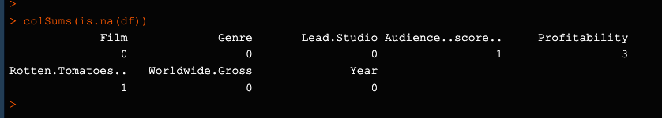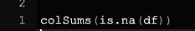

The output of colSums(is.na(df)) displays the number of missing values (NAs) in each column of the data frame df. Here's what the output signifies:

* **Film**: 0 missing values
* **Genre**: 0 missing values
* **Lead.Studio**: 0 missing values
* **Audience…score…**: 1 missing value
* **Profitability**: 3 missing values
* **Rotten.Tomatoes…**: 1 missing value
* **Worldwide.Gross**: 0 missing values
* **Year**: 0 missing values

This indicates that the "Audience…score…" and "Rotten.Tomatoes…" columns each have 1 missing value, while "Profitability" contains 3 missing values. All other columns have no missing data.

### Drop missing values

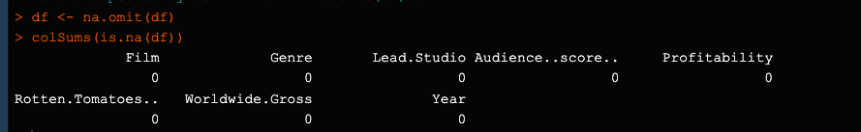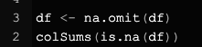

* **df <- na.omit(df)**: This command removes all rows from the data frame df that contain any missing values (NAs). After running this, only rows with complete data will remain in df.
* **colSums(is.na(df))**: After removing rows with missing values, this command checks for any remaining NAs in each column of df. It creates a logical matrix where TRUE represents an NA, and then sums the number of TRUE values (NAs) in each column, giving the count of missing values per column.

The output provided shows a table with the column names and a row with values of all zeros. This indicates that there are no missing values in any of the columns of the data frame df.

Summary Statistics

The summary(df) function in R offers a detailed summary of a data frame (df). Here's what it typically includes:

* For Numeric Columns:
* Min: The smallest value.
* 1st Qu: The 25th percentile.
* Median: The middle value (50th percentile).
* Mean: The average of the values.
* 3rd Qu: The 75th percentile.
* Max: The largest value.
* For Factor Columns:
* Levels: The distinct categories within the factor.
* Counts: The frequency of each category.
* For Character Columns:
* Length: The length of the character strings.
* Unique: The number of distinct values.
* For Logical Columns:
* Mode: The most common value (TRUE or FALSE).
* Counts: The number of TRUE and FALSE values.

This function is helpful for quickly understanding the key statistics and distribution of the data.

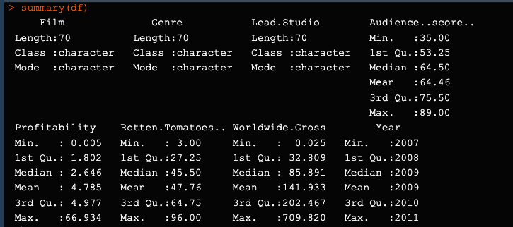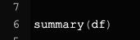

This output summarises a data frame in R, likely from the summary() function.

**Film, Genre, Lead.Studio**:

* 70 entries, all character data.

**Audience…score…**:

* Min: 35, 1st Qu.: 53.25, Median: 64.5, Mean: 64.46, 3rd Qu.: 75.5, Max: 89.

**Profitability**:

* Min: 0.005, 1st Qu.: 1.802, Median: 2.646, Mean: 4.785, 3rd Qu.: 4.977, Max: 66.934.

**Rotten.Tomatoes…**:

* Min: 3, 1st Qu.: 27.25, Median: 45.5, Mean: 47.76, 3rd Qu.: 64.75, Max: 96.

**Worldwide.Gross**:

* Min: 0.025, 1st Qu.: 32.809, Median: 85.891, Mean: 141.933, 3rd Qu.: 202.467, Max: 709.82.

**Year**:

* Range from 2007 to 2011, with a median of 2009.

This summary provides a snapshot of the data’s key statistics

## R Visualisations

#### Scatterplot

A scatterplot is a visual tool that helps us understand the relationship between two continuous variables. Here's a breakdown of its key features:

* **Axes:** Each axis represents one variable. The horizontal axis (x-axis) typically shows the independent variable, while the vertical axis (y-axis) displays the dependent variable.
* **Data Points:** Each point on the plot represents an observation, with its position determined by the values of the two variables.
* **Patterns:** Scatterplots can reveal various relationships, such as positive (upward trend), negative (downward trend), or no correlation.
* **Outliers:** They can also highlight unusual data points that might be worth investigating further.

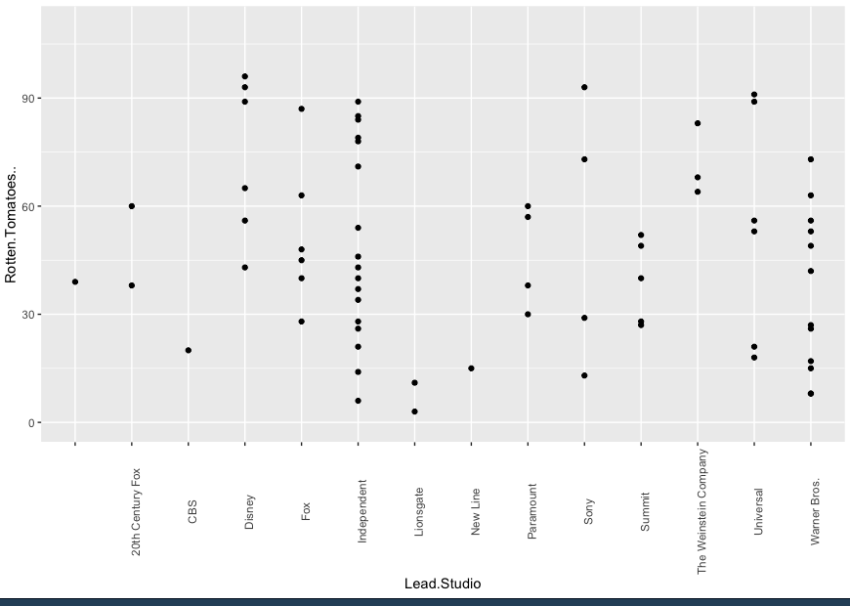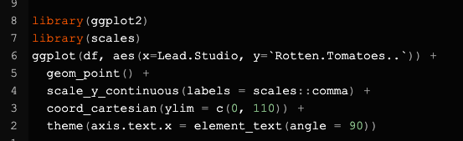Scatterplots are valuable for exploring trends, clusters, and potential anomalies in your data. They can help you identify correlations, make predictions, and gain insights into the relationships between variables.

#### Loading Libraries:

* library(ggplot2)
* library(scales)

ggplot2: Used for creating refined data visualizations.

scales: Provides functions for scaling, such as formatting axis labels.

#### Code

**ggplot(df, aes(x = Lead.Studio, y = `Rotten.Tomatoes..`)) +**

**geom_point() +**

**scale_y_continuous(labels = scales::comma) +**

**coord_cartesian(ylim = c(0, 110)) +**

**theme(axis.text.x = element_text(angle = 90))**

* ggplot(df, aes(x = Lead.Studio, y = Rotten.Tomatoes..)): Initialises the plot with data from df, mapping Lead.Studio to the x-axis and Rotten.Tomatoes.. to the y-axis.
* geom_point(): Adds points to the scatter plot.
* scale_y_continuous(labels = scales::comma): Formats the y-axis labels with commas.
* coord_cartesian(ylim = c(0, 110)): Sets the y-axis range between 0 and 110.
* theme(axis.text.x = element_text(angle = 90)): Rotates the x-axis labels 90 degrees for better readability.

This code generates a scatter plot with formatted y-axis labels and rotated x-axis labels for clearer viewing.

#### Bar chart

#### 

#### 

The code **ggplot(df, aes(x=Year)) + geom_bar()** generates a bar chart in R using the ggplot2 package:

* **ggplot(df, aes(x=Year))**: Initializes a ggplot object with the data frame df, mapping the Year column to the x-axis.
* **geom_bar()**: Adds a bar chart layer. By default, it counts the occurrences of each value in the Year column, with bar heights representing these counts.

This code creates a bar chart where the x-axis shows different years, and the y-axis displays the count of occurrences for each year.

### Export clean data

The code write.csv(df, "clean_df.csv") is used in R to save a data frame df to a CSV file named clean_df.csv:

* write.csv: This is a function in R that writes data to a CSV file.
* df: This is the data frame you want to save.
* "clean_df.csv": This is the name of the CSV file where the data frame will be saved.

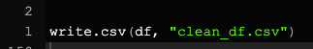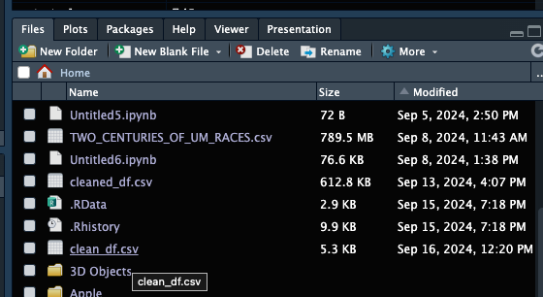When you run this code, it will create a file named clean_df.csv in your working directory, containing the data from the data frame df. This file can then be opened and viewed in any software that supports CSV files, such as Excel or a text editor.

### 

# Power BI

## Brief

For the dashboard, the company would like you to use their brand colors which are blue, green and brown. You can use light or dark shades of each colour. For example, light blue and dark blue are acceptable.

In your power BI Dashboard, the client would like to see: ​

​

* The average Rotten Tomatoes ratings of each genre​.
* The number of movies produced per year. ​
* The audience scores for each film. ​
* The profitability per studio. ​
* The worldwide gross per genre.

### Step 1

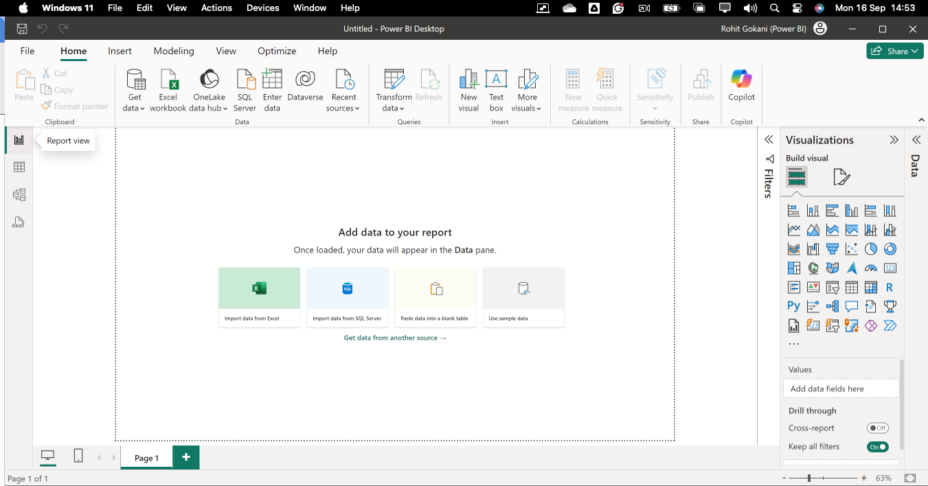Launch Power BI

Import Data

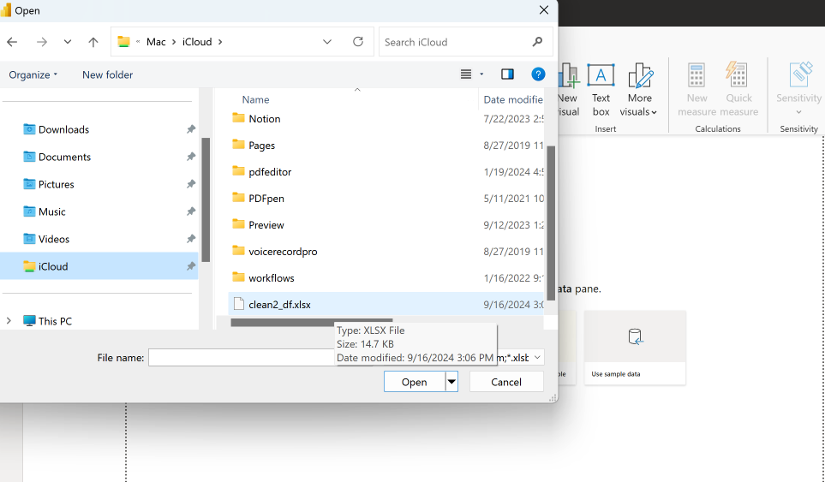

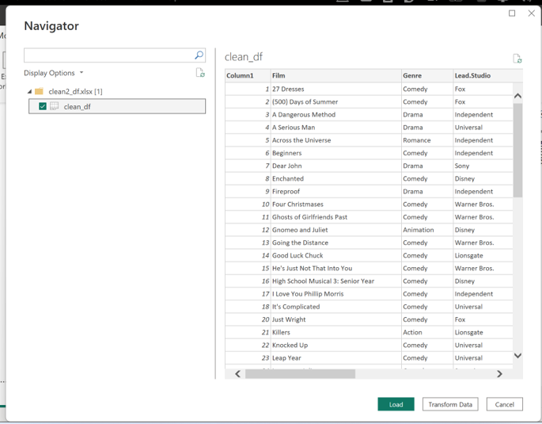 Load Data into Power BI:

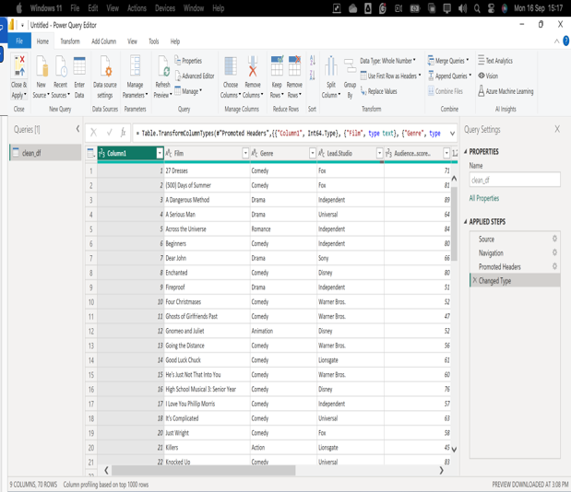

Checked all data is there.

### Visual one

The average Rotten Tomatoes ratings of each genre.

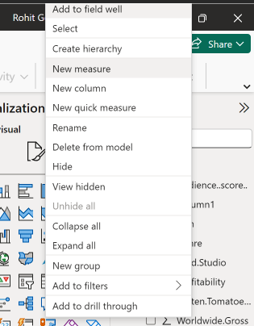

Create Calculations:

* Go to the Data view.
* Create a new measure to calculate the average rating for each genre. Use a DAX formula:

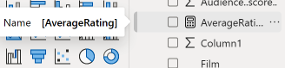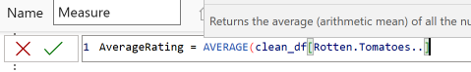

* AverageRating = AVERAGE('clean_df'[Rotten.Tomatoes..])

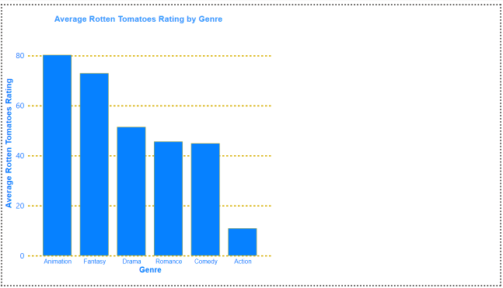

.

### Visual Two.

The number of movies produced per year:

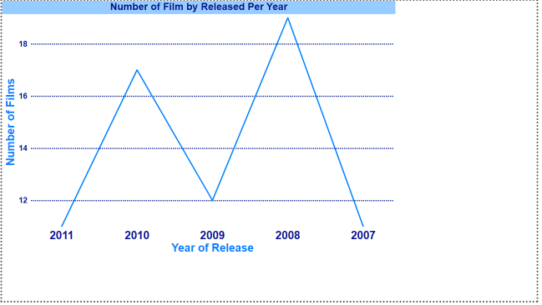

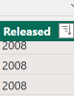A new column “Released” and the data type was converted to a text value.

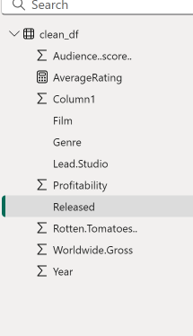

### A graph of a movie Description automatically generated with medium confidenceVisual Three

The audience score for each film:

### Visual Four

The profitability per studio:​

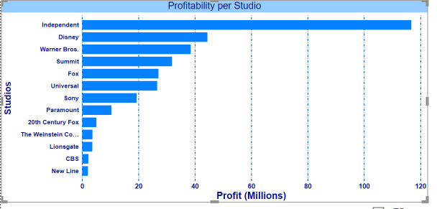

### Visual Five

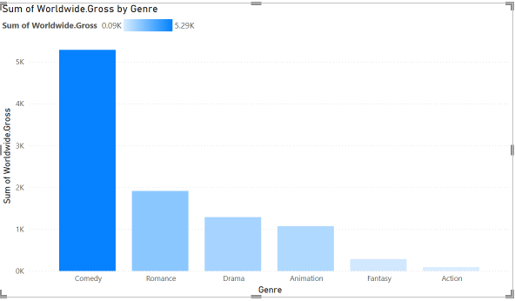

# The Polish

For the dashboard, the company would like you to use their brand colors which are blue, green and brown. You can use light or dark shades of each colour. For example, light blue and dark blue are acceptable.

### Setting the Theme

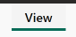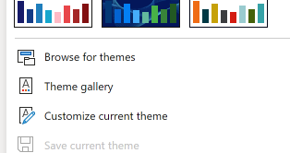

>

Colour 1 Colour 2. Colour 3

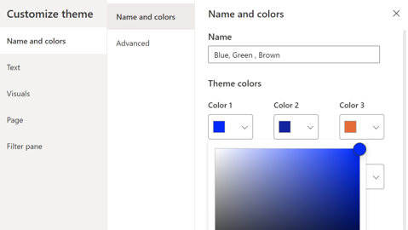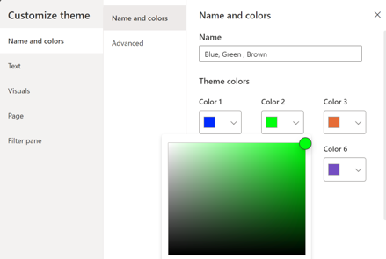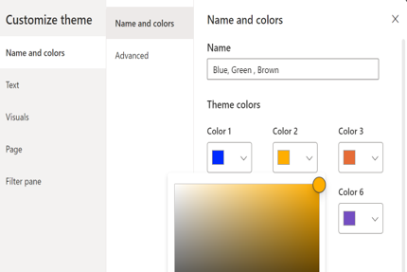

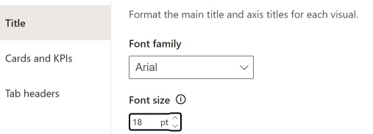Title text:

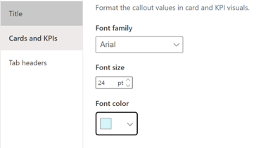Cards and KPIs text:

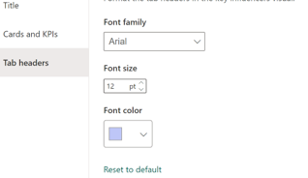Tab headers:

A simple font “Arial” was used to ensure readability.

# A collage of graphs Description automatically generatedResult

Published:

[PB2 - Power BI](https://app.powerbi.com/groups/me/reports/58eaf1ec-15c3-4877-8623-4eba991445cc/68e9d4af11bd2c909abc?experience=power-bi)

https://app.powerbi.com/groups/me/reports/58eaf1ec-15c3-4877-8623-4eba991445cc/68e9d4af11bd2c909abc?experience=power-bi